Mr. Pond
Room 321

U.S. History
SYLLABUS

COURSE DESCRIPTION
In this course students will study U.S. History in order to become more knowledgeable of past events and historical time periods so that we can positively impact the future. During this course, we will take a thematic journey through history, bouncing between past and present so that we can make relevant connections. Through this, we will examine the social, cultural, political, economic and geographic forces that shaped the United States. Additionally, in this course, students will take the U.S. and State Constitution Tests. U.S. History can be a fascinating exploration into our pasts especially when viewed from multiple perspectives.

GRADE COMPOSITION
- Quizzes There will frequently be written quizzes or projects which will count for 30-50 points each.
- Class participation – We need your voice to be heard! You should come to class ready to participate fully in the topic of the day. Your class participation grade will be determined based on the following: Each day the student must bring all relevant class materials, contribute to the learning environment in a positive manner, be respectful of others, participate in the class discussion, complete classwork as assigned, and cooperate with partners in group work. You will receive a weekly participation points chart to fill in. At the end of the week, you turn the chart into me and I will enter your add the scores to your total grade. A Maximum of 10 participation points are available per week
- Homework – Will be assigned regularly. Most assignments will be worth 10 points each unless specified by me.
- Tests (including group and individual projects given a test weight) generally count for 100 points.
- The Final Exam will count for 150 points.
- Portfolio – will consist of your binder that includes all readings, handouts, homework assignments, participation points, notes…etc! In other words, you will be turning in everything you’ve done all year! What’s the point, you ask? This will help you keep your class materials organized and can provide you with a useful resource for AP or college classes (thank you for asking). The portfolio will be worth 150 points.

GRADING SCALE
90-100 % A
80-89 % B
70-79 % C
60-69 % D
59-0 % F

CLASSROOM RULES:
- Be in your seat when the music stops.
- Discussion:
- One person speaks at a time.
- Be respectful of others opinions.
- Come prepared to participate in the discussion.
- Enjoy the discussion! We want and need to hear from you!!
- Bring your binder with all notes, handouts, graded papers, etc. to class EVERY DAY. Binders will be checked randomly and will be turned in as a final portfolio grade!
- The answer to “do we have to take notes on this?” is always “no”, but you probably should!
- Bring your book, binder, pen and notebook to each class. Participation points will be deducted for coming unprepared!

MATERIALS
You will need the following for EVERY class unless noted by the instructor:
- A People’s History of the United States 1492-Present
- A 1.5”-2” 3-ring binder with folders
- Loose leaf lined paper
- A college or wide ruled notebook (recommended)
- A USB flash drive
- Blue or black ink pens (NO Red!)
*It is critical that you have your binder by the second week of class as you will receive many handouts during this course.

COURSE OUTLINE
- Government & Leadership
  - What role should government play in the individual lives of the people?
  - What role(s) should individuals play in governmental institutions?
- Immigration & Migration
  - Is movement across national borders a human right?
- American Culture
  - What makes someone “American?”
- Invention & Innovation
  - What were the effects of U.S. inventions and innovations?
- Conflict
  - When is the U.S. justified in using force against another nation or persons?
- Protest & Rebellion
  - Is it acceptable for people to protest or rebel against their government, if so when?

LATE POLICY:
Assignments will be collected at the beginning of the period (this means assignments not printed or complete at the start of class are late!). For each day the assignment is late, one full letter grade will be deducted. The assignment will no longer be accepted after one week.

You are responsible for missed assignments caused by any absence; such missed work must be made up as soon as possible. You are responsible for scheduling a make-up examination. If you fail to do this, the grade will be recorded as a ZERO.

Typical homework assignments are worth 10 points each. Late homework may be turned in within one week for half credit.

ESSAY REWRITING:
For every test you will be expected to write an essay. You always have the opportunity to rewrite that essay once your test has been returned. The score from your old essay will be averaged with the score from your new essay. This will be your new composite score. You will have ONE week from the day the tests are handed back to hand in your rewritten essay.

ACADEMIC INTEGRITY
Plagiarism or cheating of any kind will not be tolerated. In all cases of academic dishonesty NO CREDIT will be given for the work/test/quiz. Academic dishonesty includes: plagiarizing, copying a classmate’s work, possessing another student’s assignment, and other similar instances. By turning in original work you become a better writer, thinker and learner. Academic dishonesty will be handled according to LMSA policy.

CONTACT INFORMATION:
If you have a question, a comment, or are experiencing difficulty with this class please speak with me or email me at: mpond@mrpond.org. I will be available before and after school, and I am always willing to help. Many homework assignments and handouts can be downloaded from my website: www.mrpond.org. If you misplace a handout, please check the website and download it to your computer hard drive.

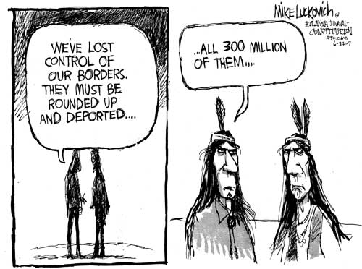
Source: http://www.truthdig.com/images/eartothegrounduploads/lkoriginalimmigration500.jpg

